**WEEK - 6 HANDSON SOLUTION**

**EXERCISE -1 :**

Create a first React file

**SOLUTIONS :**

Create a new React Application with the name “myfirstreact”, Run the application to print “welcome to the first session of React” as heading of that page.

1. To create a new React app, Install Nodejs and Npm from the following link:

<https://nodejs.org/en/download/>

1. Install Create-react-app by running the following command in the command prompt:



1. To create a React Application with the name of “myfirstreact”, type the following command:



1. Once the App is created, navigate into the folder of myfirstreact by typing the following command:



1. Open the folder of myfirstreact in Visual Studio Code
2. Open the App.js file in Src Folder of myfirstreact

**PROGRAM :**

import React from 'react';  
  
function App() {  
 const styles = {  
 textAlign: 'center',  
 marginTop: '30px',  
 fontFamily: 'Arial, sans-serif',  
 };  
  
 return (  
 <div>  
 <h1 style={styles}>Welcome to the first session of React</h1>  
 </div>  
 );  
}  
  
export default App;

**OUTPUT :**

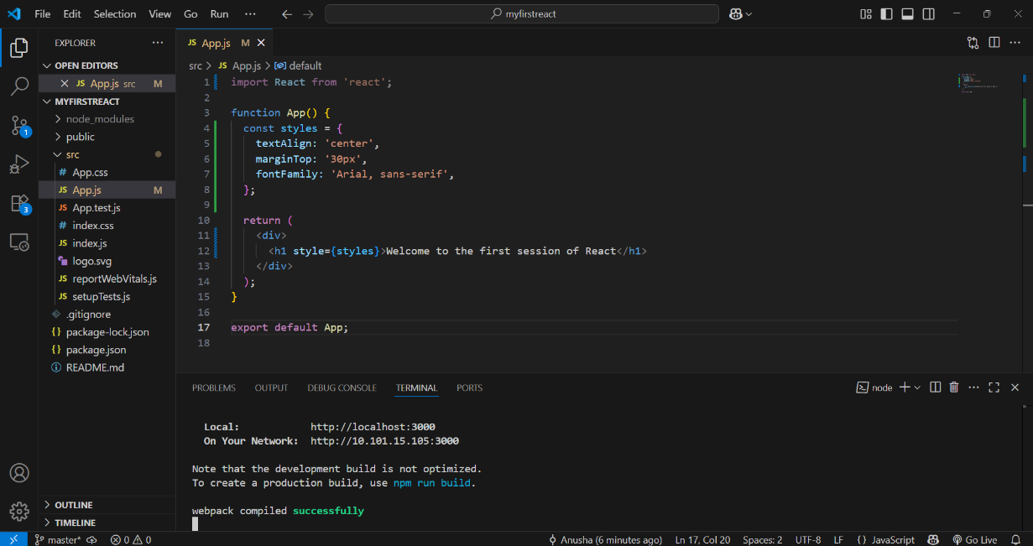

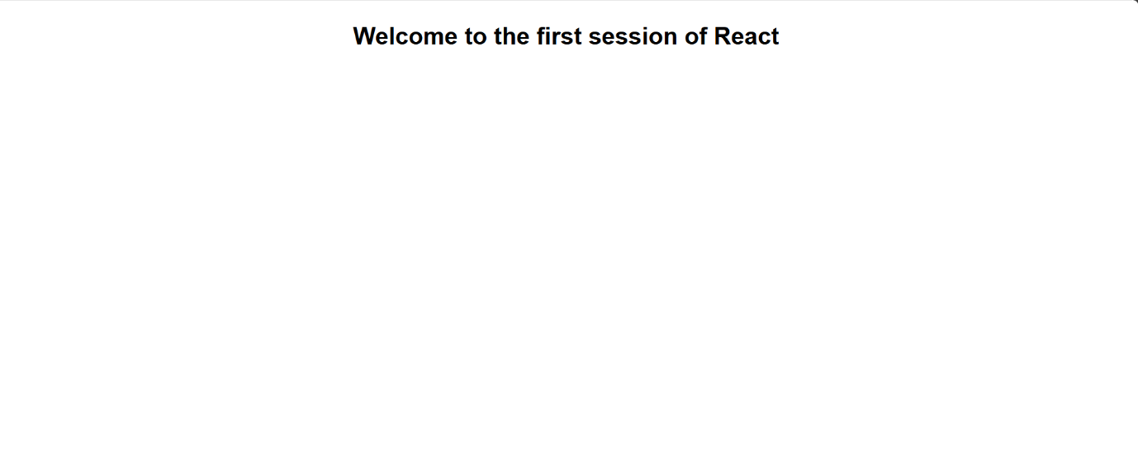

**EXERCISE - 2 :**

Create a Student Management Portal

**PROBLEM STATEMENT :**

Create a react app for Student Management Portal named StudentApp and create a component named Home which will display the Message “Welcome to the Home page of Student Management Portal”. Create another component named About and display the Message “Welcome to the About page of the Student Management Portal”. Create a third component named Contact and display the Message “Welcome to the Contact page of the Student Management Portal”. Call all the three components.

**SOLUTIONS :**

**App.js :**

import React from 'react';

import Home from './components/Home';

import About from './components/About';

import Contact from './components/Contact';

function App() {

  return (

    <div className="App">

      <Home />

      <About />

      <Contact />

    </div>

  );

}

export default App;

**COMPONENTS :**

**About.js :**

import React from 'react';

import Home from './components/Home';

import About from './components/About';

import Contact from './components/Contact';

function App() {

  return (

    <div className="App">

      <Home />

      <About />

      <Contact />

    </div>

  );

}

export default App;

**Contact.js :**

import React from 'react';

function Contact() {

  return (

    <div style={{ textAlign: 'center' }}>

      <h2>Welcome to the Contact page of the Student Management Portal</h2>

    </div>

  );

export default Contact;

**Home.js:**

import React from 'react';

function Home() {

return (

<div style={{ textAlign: 'center' }}>

<h2>Welcome to the Home page of Student Management Portal</h2>

</div>

);

}

export default Home;

**OUTPUT :**

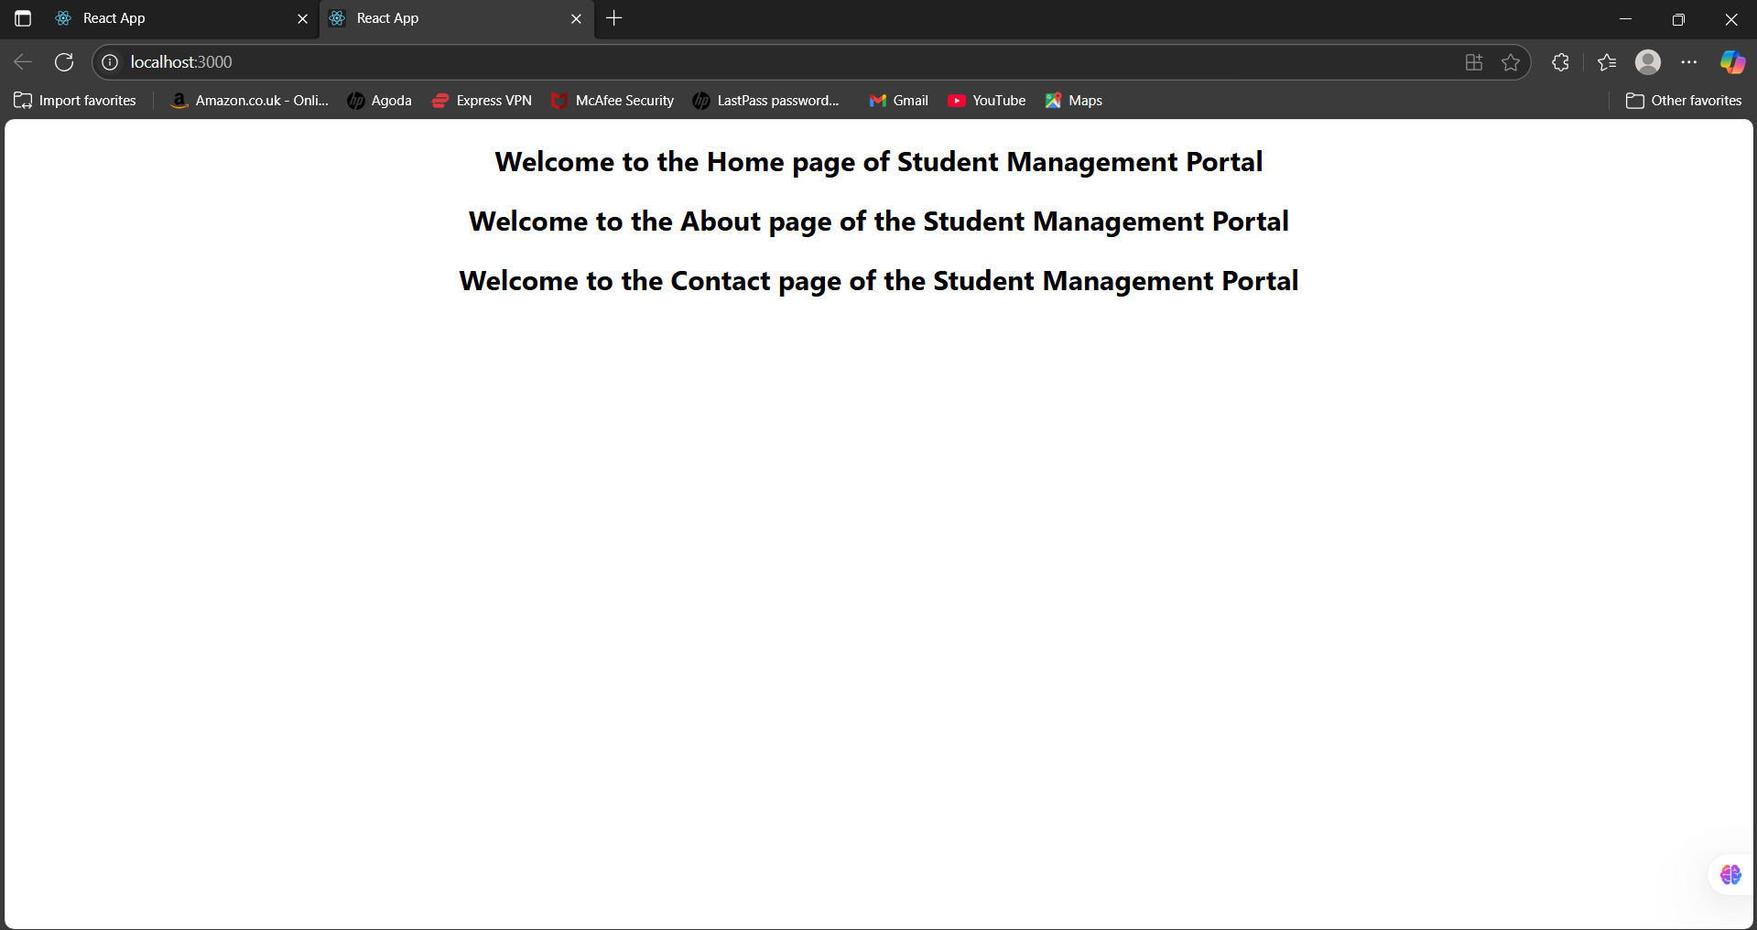

**EXERCISE - 3 :**

Create a react app for Student Management Portal for Calculate Score .

**PROBLEM STATEMENT :**

Create a react app for Student Management Portal named scorecalculatorapp and create a function component named “CalculateScore” which will accept Name, School, Total and goal in order to calculate the average score of a student and display the same.

1. Create a React project named “scorecalculatorapp” type the following command in terminal of Visual studio:



1. Create a new folder under Src folder with the name “Components”. Add a new file named “CalculateScore.js”

**SOLUTION :**

**App.js :**

import React from 'react';

import './mystyle.css';

import CalculateScore from './Components/CalculateScore';

function App() {

  return (

    <div className="App">

      <CalculateScore />

    </div>

  );

}

export default App;

**CalculateScore.js :**

import React from 'react';

import '../mystyle.css';

function CalculateScore() {

  const name = "Steeve";

  const school = "DNV Public School";

  const total = 284;

  const goal = 300;

  const average = ((total / goal) * 100).toFixed(2); // => 94.67%

  return (

    <div className="container">

      <h2 className="heading">Student Details:</h2>

      <p><span className="label">Name:</span> <span className="blue">{name}</span></p>

      <p><span className="label">School:</span> <span className="red">{school}</span></p>

      <p><span className="label">Total:</span> <span className="orange">{total} Marks</span></p>

      <p><span className="label">Score:</span> <span className="green">{average}%</span></p>

    </div>

  );

}

export default CalculateScore;

**OUTPUT :**

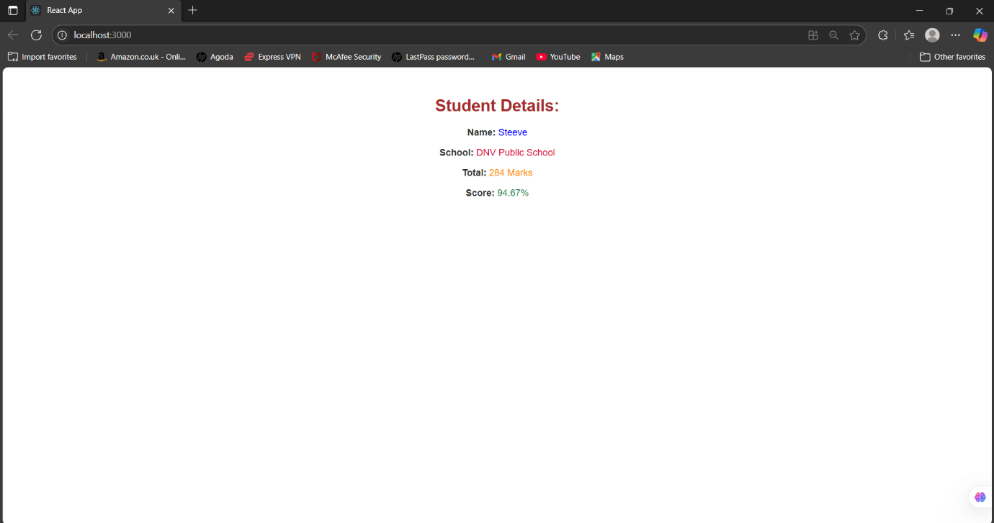

**EXERCISE - 4 :**

Create a new react application using *create-react-app* tool with the name as “blogapp”

**SOLUTION :**

**App.js :**

import React from 'react';

import Posts from './Posts';

function App() {

  return (

    <div className="App">

      <Posts />

    </div>

  );

}

export default App;

**Post.js:**

import React from 'react';

class Post extends React.Component {

  render() {

    return (

      <div style={{ border: '1px solid #ccc', margin: '10px', padding: '15px' }}>

        <h3>{this.props.title}</h3>

        <p>{this.props.body}</p>

      </div>

    );

}}

export default Post;

**ReportWebVital.js :**

const reportWebVitals = onPerfEntry => {

  if (onPerfEntry && onPerfEntry instanceof Function) {

    import('web-vitals').then(({ getCLS, getFID, getFCP, getLCP, getTTFB }) => {

      getCLS(onPerfEntry);

      getFID(onPerfEntry);

      getFCP(onPerfEntry);

      getLCP(onPerfEntry);

      getTTFB(onPerfEntry);

    });

  }

};

export default reportWebVitals;

**OUTPUT :**

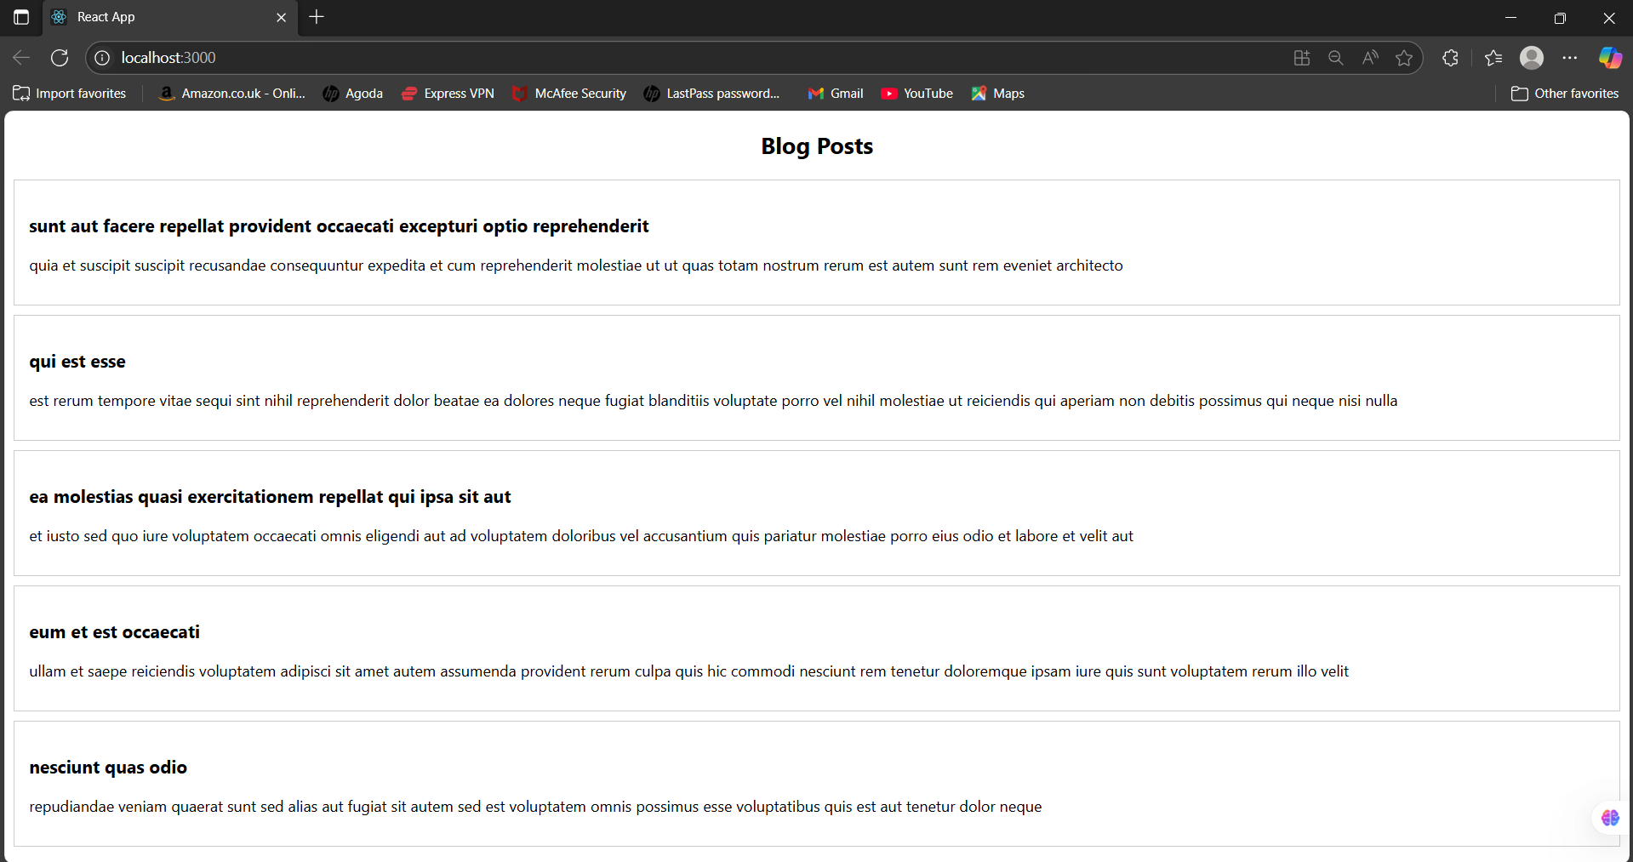

**EXERCISE - 5 :**

Create a react app for Cohort Dashboard.

**PROBLEM STATEMENT :**

My Academy team at Cognizant want to create a dashboard containing the details of ongoing and completed cohorts. A react application is created which displays the detail of the cohorts using react component. You are assigned the task of styling these react components.

**SOLUTION :**

**App.js:**

import React from 'react';

import './App.css';

import CohortDetails from './CohortDetails';

function App() {

const cohorts = [

{ id: 1, name: "React Bootcamp", status: "ongoing" },

{ id: 2, name: "Node Mastery", status: "completed" },

{ id: 3, name: "Cloud Engineering", status: "ongoing" },

];

return (

<div>

<h1>Cohort Dashboard</h1>

{cohorts.map((cohort) => (

<CohortDetails key={cohort.id} cohort={cohort} />

))}

</div>

);} export default App;

**details.js :**

import React from 'react';

import styles from './CohortDetails.module.css';

function CohortDetails({ cohort }) {

return (

<div className={styles.box}>

<dl>

<dt>Cohort Name:</dt>

<dd>{cohort.name}</dd>

<dt>Status:</dt>

<dd>

<h3 style={{ color: cohort.status === 'ongoing' ? 'green' : 'blue' }}>

{cohort.status}

</h3>

</dd>

</dl>

</div>

);

}

export default CohortDetails;

**Details.module.css :**

.box {

width: 300px;

display: inline-block;

margin: 10px;

padding: 10px 20px;

border: 1px solid black;

border-radius: 10px;

}

dt {

font-weight: 500;

}

**OUTPUT :**

